Year 7 English – Reflecting on the text-response essay
Here is an opportunity to reflect on your text response essay of THE BONE SPARROW by Zana Fraillon. Please write honestly and don’t forget to write in full sentences.
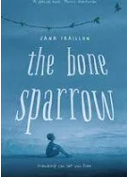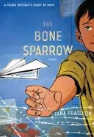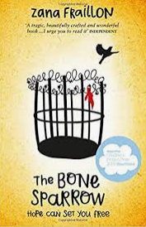
- This was the first time you have done a text-response essay. Did you find it a challenging task?

- What was the hardest part about doing this task? E.g. writing topic sentences, incorporating quotes appropriately, remembering specific examples from the book, knowing the themes

- Do you think you planned appropriately? E.g. complete the planning documents, write a draft, get feedback from the teacher, practiced embedding quotes

- During the reading of the book, did you mark out important quotes you could use in an essay?

- Do you think the activities to do with embedding quotes helped you?

- Were you satisfied with your mark?

- What was one thing you did do well? E.g. preparing, planning and writing my essay, finding appropriate quotes, finding effective examples from the book, getting feedback from my teacher, writing sentences that make sense

- What was one thing you didn’t do so well? E.g. spelling, punctuation, embed quotes correctly, write sentences that make sense, write appropriate paragraphs, finding effective examples

- What was at least one comment the teacher made about your essay?

- In the future, what would you do differently when an approaching a task like this?

- Did you enjoy studying this book doing this CAT?

